# **SQL 15 Bussiness PROBLEMS**

1. **Count the number of movies vs TV shows?**

select

TYPE,

COUNT(*) AS TOTAL_CONTENT

from netflix

GROUP BY TYPE

**Sample Output:**

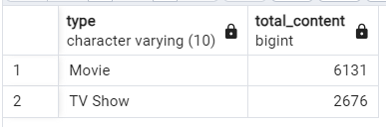

2.**Find The Most Common rating for Movies and Tv Shows?**

SELECT

TYPE,

RATING

FROM

(

SELECT

type,

rating,

COUNT(*),

RANK() OVER(PARTITION BY TYPE ORDER BY COUNT(*) DESC) AS RANKING

FROM NETFLIX

GROUP BY 1, 2

) AS T1

WHERE

RANKING = 1

**Sample Output:**

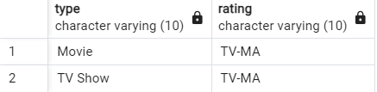

3.List All Movies Released in a specific year(e,g., 2020)

select title,release_year

from netflix

where release_year = 2020 and type = 'Movie'

select title

from netflix

where type = 'Movie'

**Sample Output:**

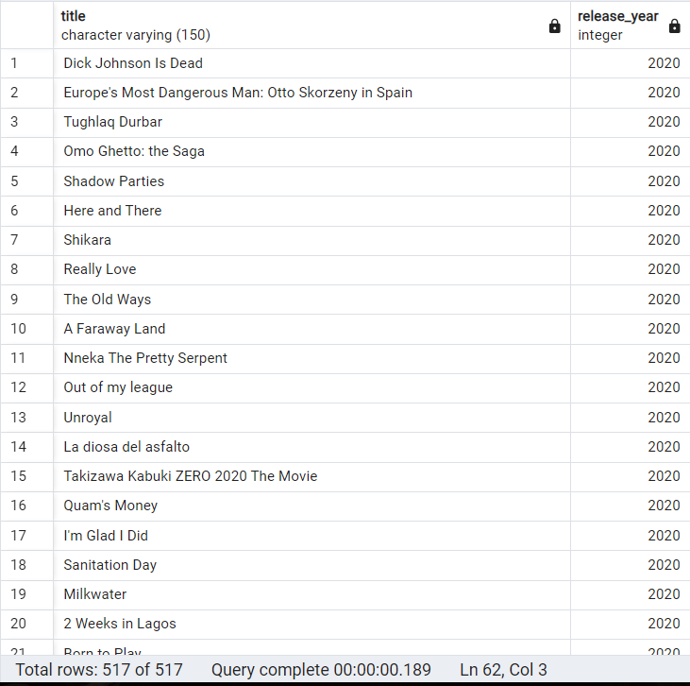

**4.Find the Top Content with the Most Conten on Netflix?**

select

unnest (string_to_array(country,',')) as new_country,

count(show_id) as total_content

from netflix

group by 1

order by 2 desc

limit 5

**Sample Output:**

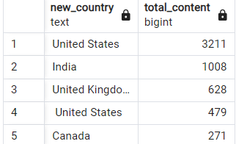

**5. Identify the Logest Movie?**

select *from netflix

where

type = 'Movie'

and

duration = (select max(duration) from netflix);

**Sample Output:**

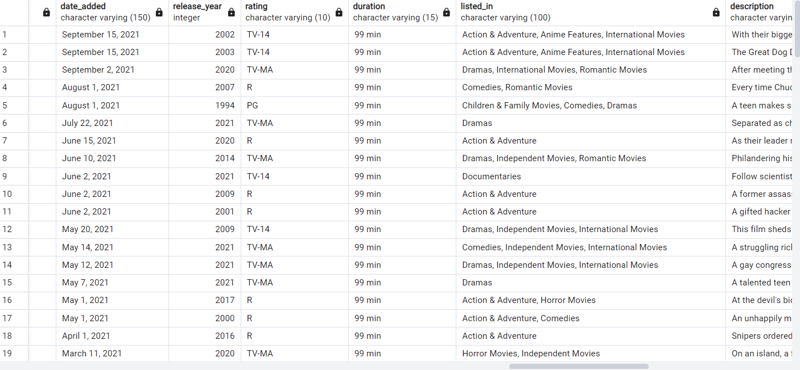

**6.find movie added in the Last Year?**

select type,date_added

from netflix

where

to_date(date_added, 'Month DD,YYYY' )>= current_date - interval '5 years' and type='Movie';

**Sample Output:**

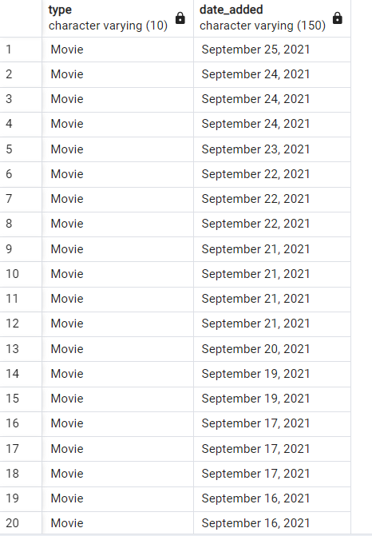

**7. Find all the Movies/tv Shows by Director 'Rajiv Chilaka'**

select * from netflix

where director ilike '%Rajiv Chilaka%'

**Sample Output:**

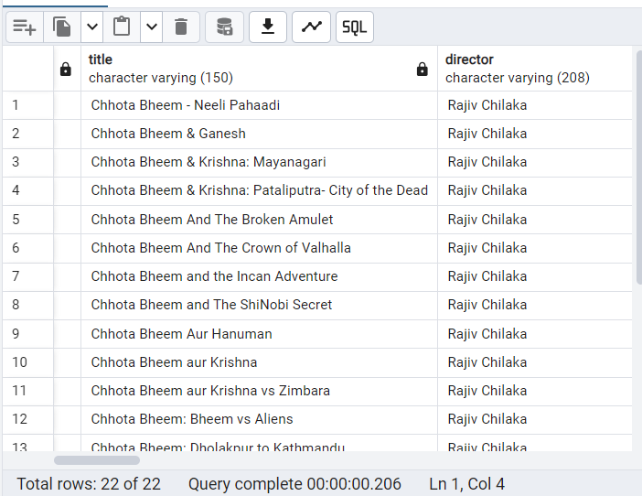

**8.List all TV shows with more than 5 sesoans?**

select * from netflix

-- SPLIT_PART(duration,'',1) AS SESSIONS

where

type = 'TV Show'

and

SPLIT_PART(duration, ' ' ,1)::numeric > 5

**Sample Output:**

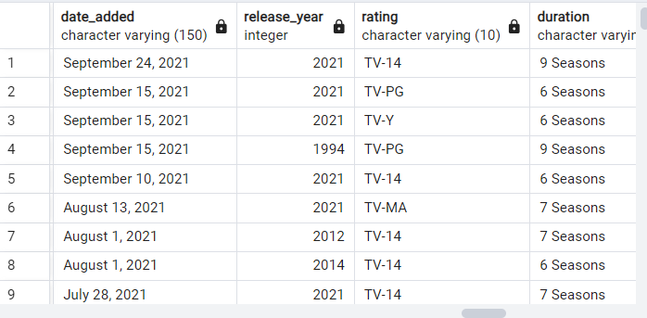

**9.Count The Number of content items in eash genre?**

select

UNNEST(string_to_array(listed_in,',')) AS GENRE,

COUNT(Show_id) as Total_content

from netflix

group by 1

**Sample Output:**

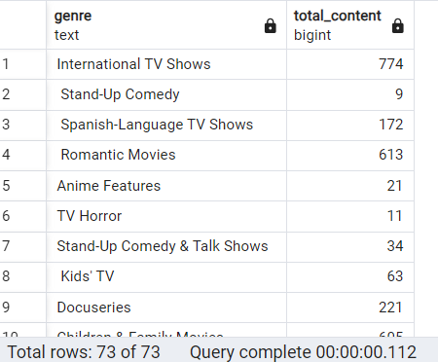

**10.Find each year and the average number of content release by indian**

**-- on netflix return top 5 year with highest avg content release?**

select

EXTRACT(YEAR FROM TO_DATE(date_added, 'Month DD, YYYY')) as YEAR,

count(*) as yearly_conten,

round(

COUNT(*)::numeric/(SELECT count(*) FROM NETFLIX WHERE COUNTRY = 'India')::numeric * 100

,2)as avg_content_peryear

from netflix

where country = 'India'

GROUP BY 1

**Sample Output:**

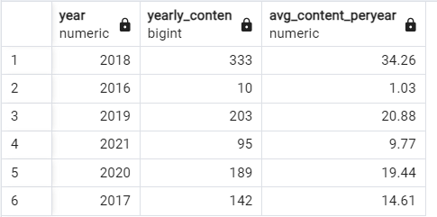

**11. List all movie thats are documentaries?**

select title as movies ,listed_in as genre

from netflix

where listed_in ilike '%Documentaries%'

**Sample Output:**

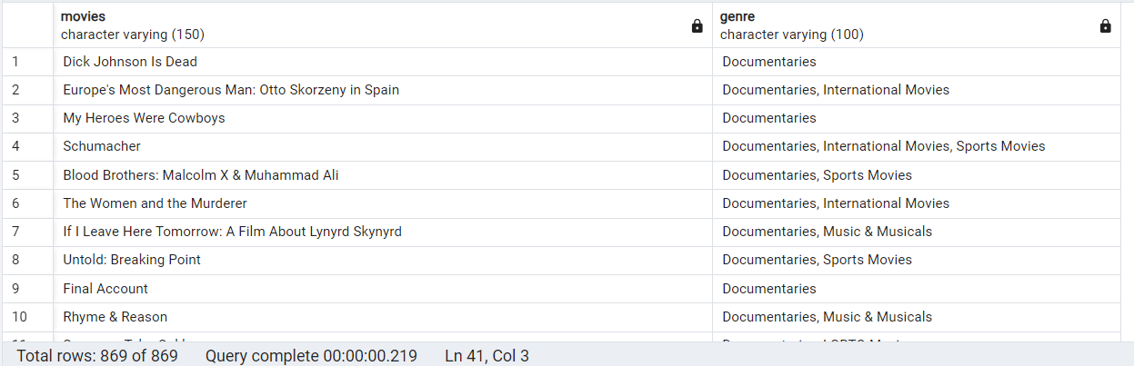

**12. find all content without a directot?**

select show_id,title,director

from netflix

where director is null

**Sample Output:**

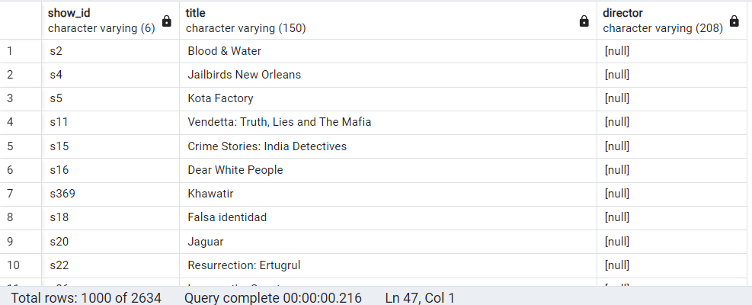

**13.Find how many movies actor 'Salman Khan' appeared in last 10 year?**

select CASTS,RELEASE_YEAR

from netflix

where

casts ilike '%Salman khan%'

and release_year >EXTRACT(YEAR FROM CURRENT_DATE) – 10

**Sample Output:**



**14.Find th top 10 actors who have appeared in the highest**

-- number of movies produced in india?

select

unnest(string_to_array(casts,',')) as actors,

count(*) as total_content

from netflix

where country ilike '%india'

group by 1

order by 2 desc

limit 10

**Sample Output:**

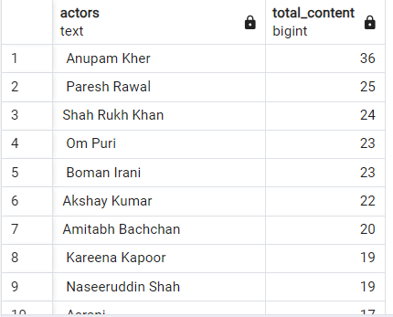

**15.Categorize the content based on the presence of the keywords 'kill'**

**-- and 'violence' in the description field. Label content containing these**

**-- keywords as 'Bad' and all other content as 'Good'. Count how many items**

**-- fall into each category?**

with new_table

as

(

select

*,

case

when description ilike '%kill%' or

description ilike '%violence%' then 'bad_content'

else 'good_content'

end category

from netflix

)

select

category,

count(*) as total_content

from new_table

group by 1

**Sample Output:**

